Set MySQL new connection.

* Email with password and user name;

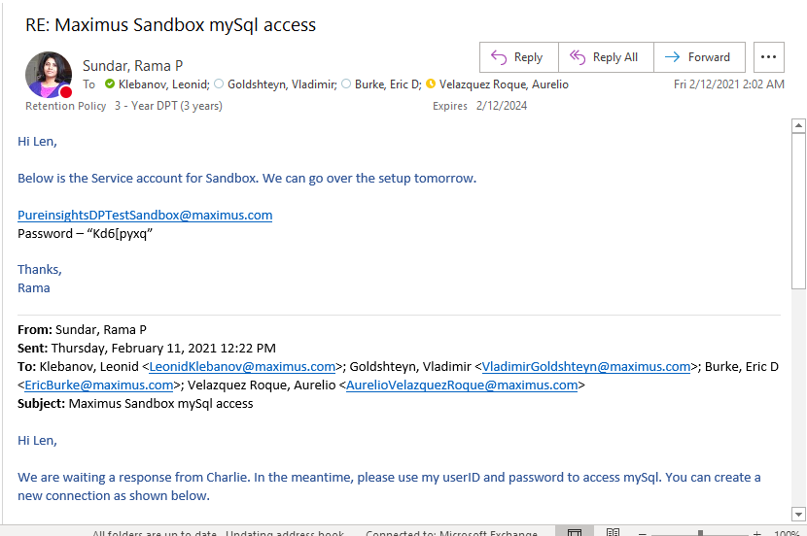

* Access to MySQL app

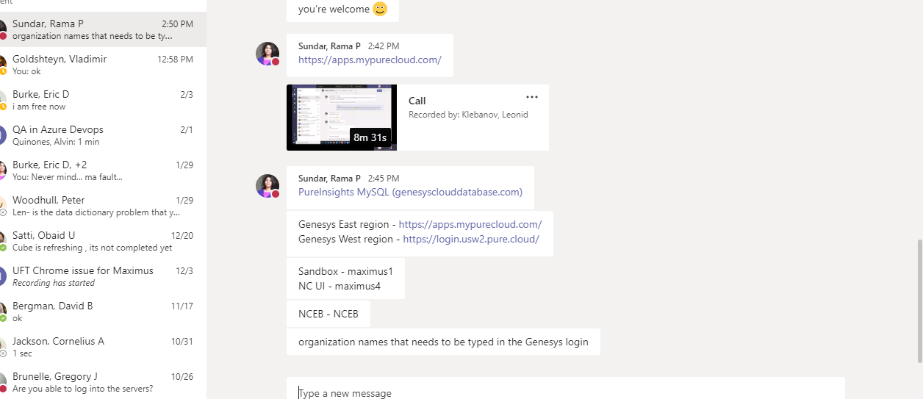

[2:42 PM] Sundar, Rama P

<https://apps.mypurecloud.com/>

​

[2:45 PM] Sundar, Rama P

[PureInsights MySQL (genesysclouddatabase.com)](https://mysql.genesysclouddatabase.com/config)

​

[2:49 PM] Sundar, Rama P

Genesys East region - <https://apps.mypurecloud.com/>

Genesys West region - <https://login.usw2.pure.cloud/>

​

[2:49 PM] Sundar, Rama P

Sandbox - maximus1

NC UI - maximus4

​

[2:49 PM] Sundar, Rama P

NCEB - NCEB

​

[2:50 PM] Sundar, Rama P

organization names that needs to be typed in the Genesys login

* Create connection

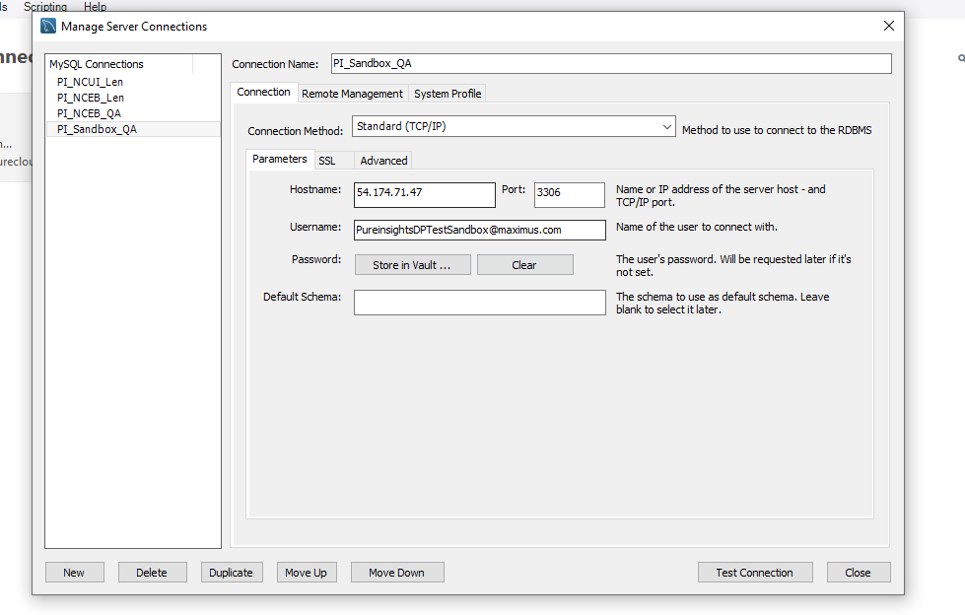

* Create ODBC connection